# [**Chris Meloni, Mariska Hargitay Reunite Ahead of Law & Order Reconciliation**](https://tvline.com/2020/07/19/chris-meloni-mariska-hargitay-reunion-law-and-order-svu-photo/amp/?__twitter_impression=true)

* Michael Ausiello
* July 19, 2020 6:59PM PDT

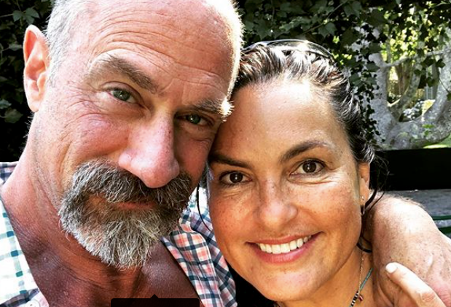

Courtesy of Mariska Hargitay/Instagram

In case you hadn’t heard, the Benson/Stabler reunion is “on” — and [Mariska Hargitay](https://tvline.com/tag/mariska-hargitay/) has the photo to prove it.

Less than two weeks after [Christopher Meloni](https://tvline.com/tag/christopher-meloni/) confirmed that his forthcoming return to the *Law & Order* universe will [include a reunion](https://tvline.com/2020/07/07/law-and-order-svu-benson-stabler-reunion-christopher-meloni/) between his Stabler and Hargitay’s Benson, Hargitay on Sunday shared a fresh photo of her and her former leading man on Instagram. The pic was captioned, simply, “It’s on.”

[2020 Fall TV Preview: Guide to All the New Comedies and Dramas](https://tvline.com/gallery/fall-new-tv-shows-preview-photos-2020/?ref=https://tvline.com/2020/07/19/chris-meloni-mariska-hargitay-reunion-law-and-order-svu-photo/)

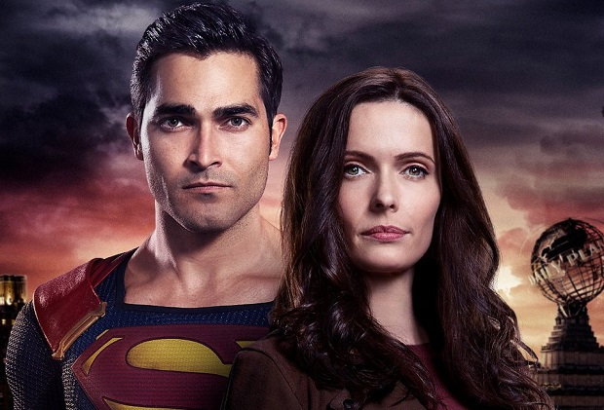

[Launch Gallery](https://tvline.com/gallery/fall-new-tv-shows-preview-photos-2020/?ref=https://tvline.com/2020/07/19/chris-meloni-mariska-hargitay-reunion-law-and-order-svu-photo/)

As previously reported, Meloni will return to the *Law & Order* franchise this fall in a Stabler-centric new series subtitled [*Organized Crime*](https://tvline.com/tag/law-order-organized-crime/)*.* His comeback is expected to include his first appearance on [*Law & Order: SVU*](https://tvline.com/tag/law-order-svu/) since exiting the show nearly a decade ago. (Meloni departed *SVU* after negotiations related to his contract broke down at the end of Season 12. When Season 13 started, Stabler had retired from the police force without saying anything to his tight-knit co-workers; Olivia learned the devastating news at the same time as the audience did.)

“Benson and Stabler are inextricably linked, locked and connected,” Meloni recently told the *New York Post*. “I think there is truly and deeply a worthwhile, inherent drama in exploring that relationship and the complexity of how Stabler left — the unresolved emotions both characters feel and how the fans feel.”

### **Popular on TVLine**

“How my character left was really unsatisfying, I think,” he continued, before adding that the possibility exists of shooting multiple *SVU*–*Organized Crime* crossover episodes. “People will always be hungry to see how we interact and how that dynamic has changed.”

NBC ordered *Organized Crime* to series back in March; production is expected to get underway next month. The spinoff is slated to air Thursdays at 10/9c in the fall and, per the official logline, will follow Stabler as he “returns to the NYPD to battle organized crime after a [devastating personal loss](https://tvline.com/2020/06/16/law-and-order-svu-spinoff-stabler-death-dies-organized-crime/).”

Check out Hargitay’s Instagram post below:

